|  |  |
| --- | --- |
| **Name** | Manish Shashikant Jadhav, Mayur Krishna Solankar |
| **UID** | 2023301005, 2023301018 |
| **Subject** | Software Engineering |
| **Experiment No.** | 10 |
| **Aim** | Devops |

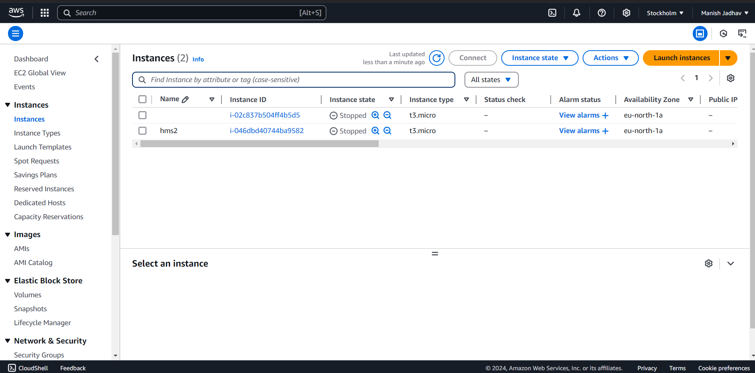

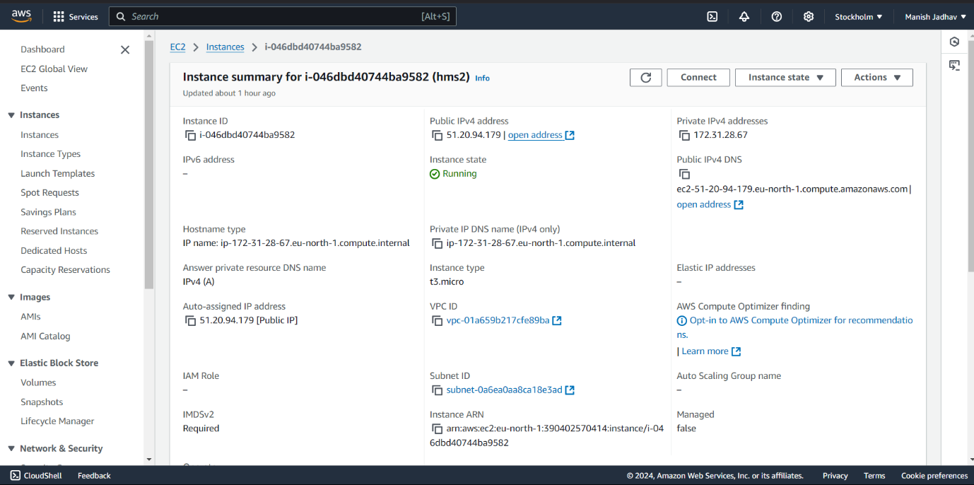

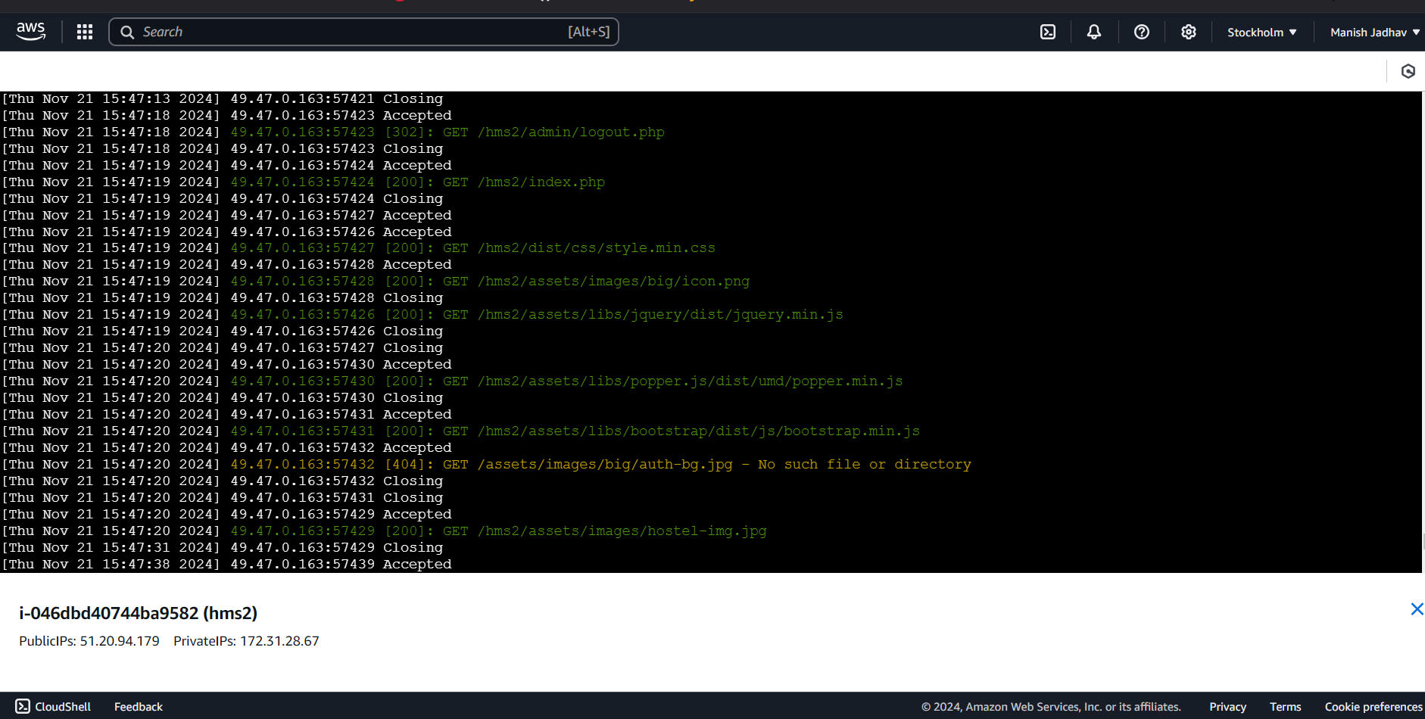

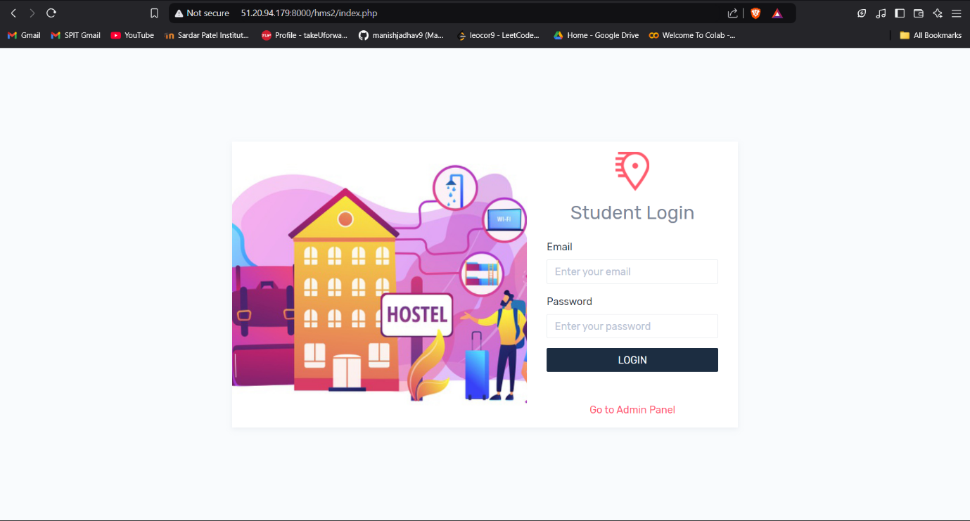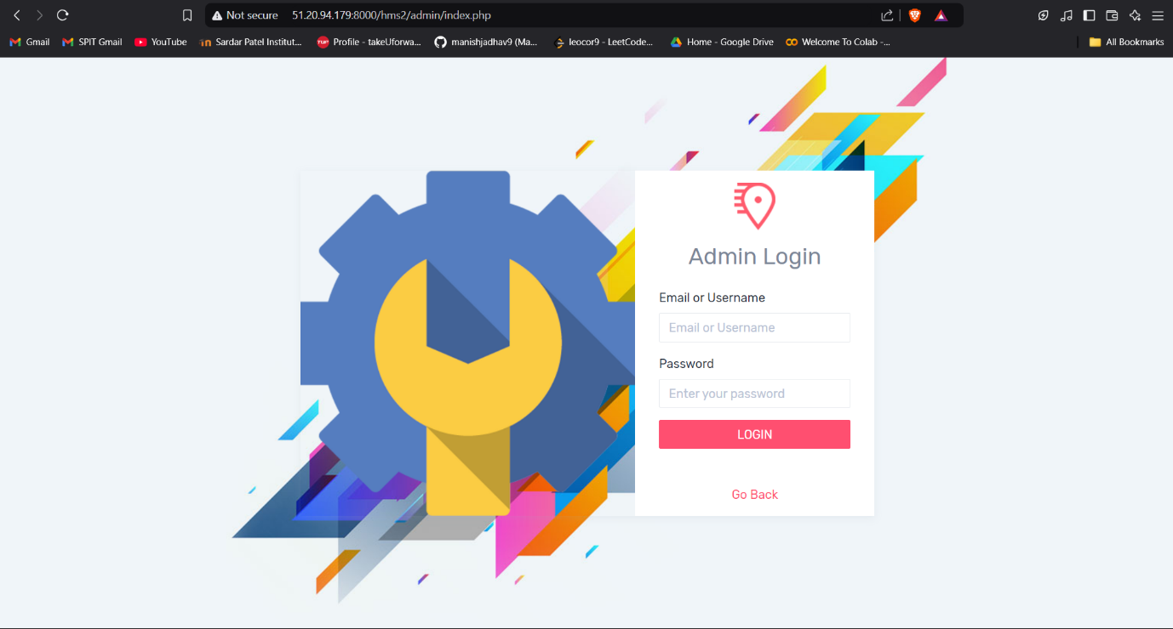

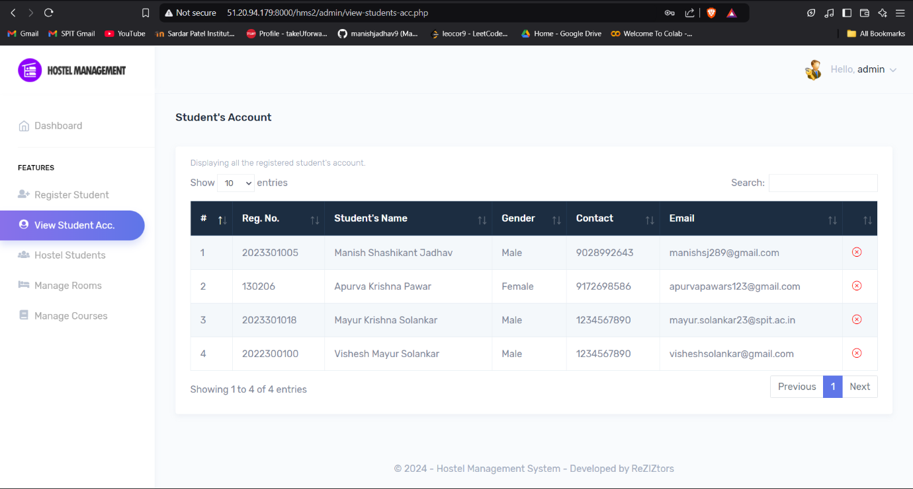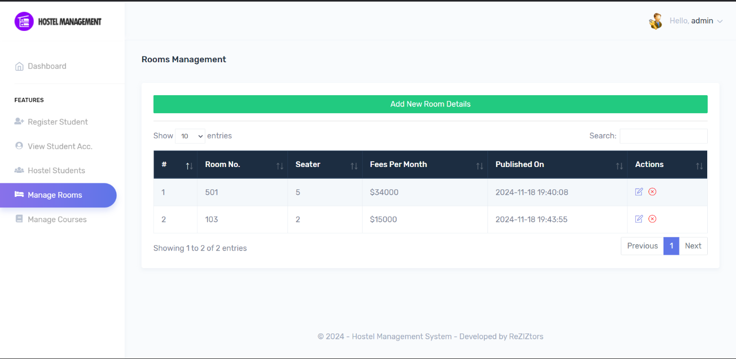

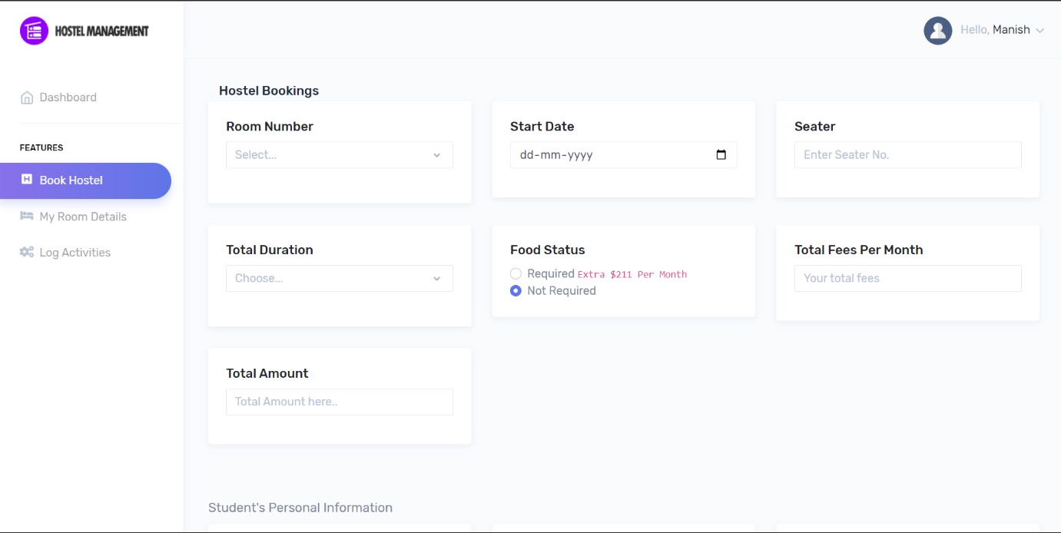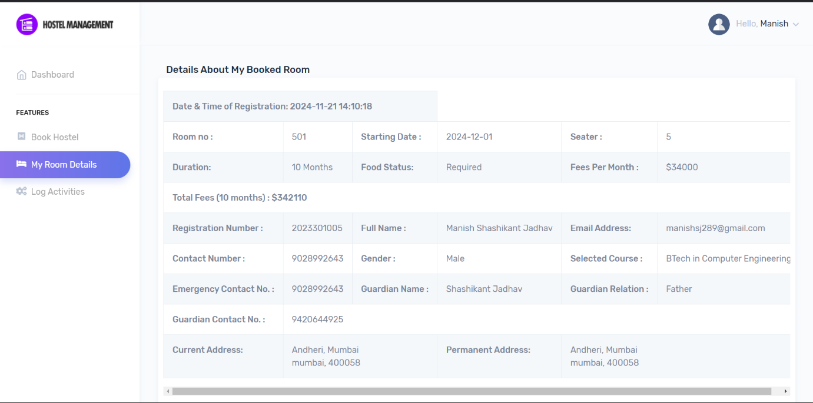

|  |  |
| --- | --- |
| **Conclusion** | Hence by completing this experiment we came to know how to use devops. |